**Question 1- Minimum Wages and Employment**

**1)**

In this paper, economists David Card and Alan Krueger studied the minimum wage effect on employment by observing the effects of the law of the minimum wage increase ($4.25 to $5.05 per hour) in New Jersey and comparing it the data from Pennsylvania where kept their minimum hourly wage at $4.25. The main research question of this study is “What is the impact of a minimum wage increase on employment?”. In many Economy fields, unemployment and inflation are main subjects of studies for the aim of understanding the behavior of these terms with the causality in the background. The results obtained from the researches and studies provide a better perspective to policy-makers which might help them generate better solution for these problems in order to improve public wealth and the economy of their country.

To evaluate the impact of minimum wage increase, 410 fast-food restaurants were surveyed in New Jersey and Pennslyvania before and after the rise. Comparing the employment growth at stores in Pennsylvania and New Jersey, provides estimations of the effect of higher minimum wage. The paper uses the survey results (from 410 stores) as the major data and the methodology goes as the statistical analyzes used in tables such as regression models, T tests etc. To mention the related tables in Question 2, Question 3 and Question 4 (respectively Table 3, Table 4 & Table 7);

* Table 3 shows the average employment per store before and after the minimum wage increase in New Jersey. The results seperated into categories by state (Pennsylvania, New Jersey), starting wage and differences between sub-categories.
* Table 4 shows the change in Employment after the minimum wage increase comparing New Jersey and Pennsylvania gradaully controlling some other variables such as chain, ownership, region etc.
* Table 7 presents the change in the price of a full meal (price of medium soda + price of small fries + price of entree – tax included) after the minimum wage increase comparing New Jersey and Pennsylvania gradaully controlling some other variables same as the Table 4.

These empricial analysis on the survey results indicates the purpose of the research as finding the effects of the minimum wage increase law on employment and prices, using various econometric methods (regression, tests and build better models by categorizing data with controlled external effects).

**2)**

Average Employment Per Store Before and After the Rise in New Jersey Minimum Wage

|  |  |  |  |  |  |
| --- | --- | --- | --- | --- | --- |
|  |  | Stores by state | | |  |
|  | (1) | | (2) | (3) | |
| VARIABLES | PA | | NJ | NJ-PA | |
|  |  | |  |  | |
| FTE employment before  all available observations | 23.33 | | 20.44 | -2.89 | |
|  | (1.351) | | (0.508) | (1.443) | |
| FTE employment after  all available observations | 21.17  (0.943) | | 21.03  (0.520) | -0.14  (1.077) | |
|  |  | |  |  | |
|  |  | |  |  | |

Duplicated table above, shows the change of average full time equivalent employment per store after the minimum wage increase in New Jersey, by comparing results from New Jersey and Pennsylvania. First column indicates that after the minimum wage increase in New Jersey, average FTE employment per store has decreases from 23.33 to 21.17. Second column contrarily points the positive change in New Jersey. Minimum wage incrase policy in New Jersey has resulted with an increase on average FTE employment per store (20.44 to 21.03). When we compare the standard errors, the New Jersey results have remarkably smaller which indicates that the observations are closer to the fitted regression line in New Jersey. Third column displays the differences of the average FTE employment per store between New Jersey and Pennsylvania before and after the policy. Before the minimum wage increase in New Jersey, it can be seen that the average FTE employment per store in Pennsylvania is 2.89 more than New Jersey’s average. This number after the min-wage increase, drops to 0.14 which clearly indicates the increase in full time equivalent employment of New Jersey helps it close the gap between Pennsylvania. Based on the these statistics from Table 3, estimated impact of minimum wage increase seems to be an increase of the average FTE employment per store of the affected states.

**3)**

Change in Employment

|  |  |  |
| --- | --- | --- |
|  |  |  |
| Independent variable | (1) | (2) |
|  |  |  |
| New Jersey Dummy | 2.277 | 2.282 |
|  | (1.19) | (1.20) |
| Initial wage gap | - | - |
|  |  |  |
| Controls for chain and ownership | no | yes |
|  |  |  |
| Controls for region | no | no |
|  |  |  |
| Standard error of regression | 8.71 | 8.72 |
|  |  |  |
| Probability value for controls | - | 0.34 |

Column (i)

$$FTEdiff=-1.879+2.277NewJerseyDummy$$

Column(ii) 🡪 Burger King as reference

$$FTEdiff=-1.450+2.282NewJerseyDummy+0.373co_{owned}$$

$$+0.235KFC-2.085ROYS-0.757WENDYS$$

In the Table 4, New Jersey Dummy is a binary variable that equals 1 when state is New Jersey and equals 0 when state is Pennsylvania. The purpose of using New Jersey Dummy is exhibiting the effect of state in the FTE change before & after the minimum wage increase. Since the min-wage increase came into force in New Jersey we need to compare it with not-affected state which is Pennsylvania in our case. In first column the coefficient of New Jersey Dummy is 2.277 which tells us that the change in average FTE per store increases by 2.277 when the state is New Jersey. Similarly in second column, change in average FTE per store increases by 2.282 in New Jersey compared to Pennsylvania (when we control for chain and ownership). The conclusion is that the change in employment (after – before) increases when the subject is New Jersey, possibly caused by the minimum-wage increase policy. The specification in Column 2 helps us to control some external factors that might cause a bias in our observed variable’s coefficient when they are omitted. These controls are categorical chain variables and information of whether or not the store is company owned. When we take Burger King as our reference (no variable for Burger King), KFC, Wendys and Roys becomes our new variables that isolate the biased effects from New Jersey Dummy. Likewise, dummy variable co_owned is also added to the model in order to control company ownership effect. The specifications in the model of Column 2 get us a better, realistic and less biased estimation in contrast to simpler calculations in Question 2 and Column 1. Controlling chain and ownership prevents eliminates some of the biases and makes the model more explanatory.

**4)**

|  |  |  |
| --- | --- | --- |
|  |  |  |
| Independent variable | (1) | (2) |
|  |  |  |
| New Jersey Dummy | 0.033 | 0.037 |
|  | (0.014) | (0.014) |
| Initial wage gap | - | - |
|  |  |  |
| Controls for chain and ownership | no | yes |
|  |  |  |
| Controls for region | no | no |
|  |  |  |
| Standard error of regression | 0.101 | 0.097 |
|  |  |  |

Change in the Price of a Full Meal

As seen above, Replication of Table 7 is formed for observing the change in the full meal prices after the New Jersey’s minimum wage increase and comparing the observed effects on two states. Some possible research questions that encouraged the economists to collect these statistics and built this table might be “What is the effect of minimum wage increase in New Jersey on the price of a full meal?”, “After the minimum wage increase in New Jersey, how has the price of a full meal changed for Pennsylvania and New Jersey?” or more general “Does minimum wage increase cause a change in meal prices?”. Similar to the Question 3’s Table 4, we have two columns. In first one we have a simpler model that we are not controlling chain and ownership, In second one we control for chain and ownership in order to obtain less biased New Jersey Dummy that estimates the effect of New Jersey better. The coefficient of the New Jersey Dummy in the second column is 0.037 which indicates that change in the price of a full meal increases by 3.7% when the state is New Jersey (for New Jersey, the change in full meal price is 3.7 percent more than Pennsylvania’s full meal price change). Thus, minimum wage increase resulted in a steeper rise in the full meal price in New Jersey although it causes an increase in the average FTE employment. Higher employment was followed by the increase in prices at higher rates (more than not-policy affected Pennsylvania).

All in all, mixed evidences from the table shows that as the average number of employees of these chains gruadually goes up with the min-wage increase, stores run higher prices for fast-food meals which might be a reperation of the expenses caused by the combination of more employment and higher wages.

**Question 2 - Impact of Traffic Laws**

**1)**

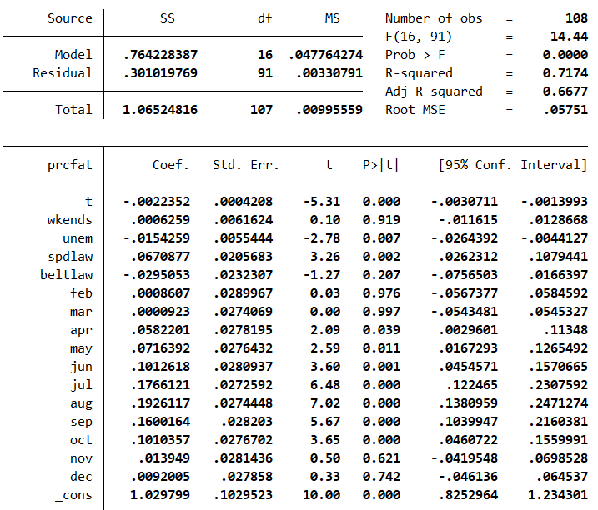

When we run OLS regression of prcfat on a linear time trend with monthly dummy variables and the variables such as wkends, unem, spdlaw, beltlaw we obtain the model above. Now we are going to discuss our findings by interpreting coefficients;

* If number of weekends in month increases by one, the percent of fatal accidents increases by 0.00063 percentage points. The coefficient here is statistically insignificant (p-value = 0.919).
* One percentage point increase of the state unemployment rate, decreases fatal accidents share by 0.0015 percentage points. The coefficient of unem is statistically significant since the p-value equals 0.007.
* Higher speed limits (spdlaw == 1) increases the share of fatal accidents by 0.067 percentage points. The coefficient of spdlaw is statistically significant (p-value = 0.002).
* Seatbelt law decreases the the percent of fatal accidents by 0.03 percentage points. Seatbelt law’s coefficient is statistically insignificant because its p-value is 0.207.

Since we took January as a reference (to avoid perfect collinearity), March has the minimum effect and August has the maximum effect on fatal accidents.

* In March, the percent of fatal accidents is 0.000092 percentage points more than January. The coefficient of March is not statistically significant (p-value = 0.997).
* In August, the percent of fatal accidents is 0.193 percentage points more than January. August’s coefficient is statistically significant, its p-value is almost 0.

In this case the month with lowest fatal accident rate is January (no monthly dummy variable with negative coefficient) and the month with highest rate is August.

As might be expected, the new seatbelt law is lowering the fatality of the accidents and higher speed limits increases it. However, the interesting thing here is that the economic activity (lower unemployment rate and weekends) has an additive effect on the share of fatal accidents. It might be caused by international trucks. The final deduction is the higher rates of fatality in summer months.

**Question 3 - Policy Analysis**

**1)**

Using the Kentucky data, estimating the model by adding *male, married*, set of industry (*manuf, construc*) and injury type dummy variables (*head, neck, trunk, lowback, lowextr, occdis*) the resulting estimated regression model becomes as follows;

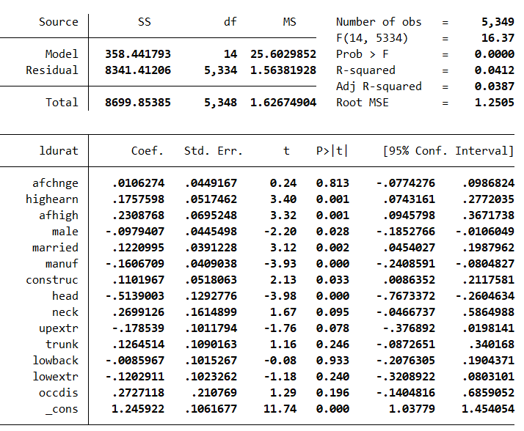

To interpret the estimated regression model with extra explanatory variables;

* After change in benefits, duration of benefits increases by 1.06 percent.
* After change in benefits, high-income workers’ duration of benefits increases by 23.09 percent. (interaction-term)
* If worker is high earner, duration of benefits increases by 17.58 percent.

**The Regression Model without Extra Explanatory Variables**

|  |  |
| --- | --- |
|  |  |
| VARIABLES | ldurat |
|  |  |
| afchnge | 0.00766 |
|  | (p: 0.864) |
| highearn | 0.256*** |
|  | (p: 0.000) |
| afhigh | 0.191*** |
|  | (p: 0.005) |
| Constant | 1.126*** |
|  | (p: 0.000) |
|  |  |
| Observations | 5,626 |
| R-squared | 0.021 |

Standard errors in parentheses

*** p<0.01, ** p<0.05, * p<0.1

$$log\left(durat\right)=1.126+0.0077afchnge+0.256highearn+0.191afhigh$$

The estimation of the *afhigh*(afchnge*highearn) variable’s coefficient is 0.191 in the simpler model above and the coefficient of the same varaible is estimated as 0.2308 in the model with extra explanatory variables such as *male, married*, *manuf, construc*, *head, neck, trunk, lowback, lowextr* and *occdis.* The p-value of the *afhigh’*s coefficient is 0.001 in the complex model which makes the coefficient statistically significant at 1% level of significance (0.001<0.005 = 0.01/2).

In the model with controlled factors (with more variables), the coefficient and t-statistic of *afhigh* has increased and the p-value has decreased, which makes the *afhigh* more significant and effective to duration on benefits.

*Afchnge* is the dummy variable for observations after the policy change, and *highearn* points the highearners. As a treatment group, high-income workers tend to respond the new policy of the raised cap on weekly earnings substantially since the policy makes it cheaper for a high earner worker to stay on worker’s compensation. *afchnge* alone is statistically insignificant and has a trivial coefficient but *afhigh* is statistically significant (interaction term). By interpreting the complex model (with more controlled variables), the duration of compensation (benefits) increased by almost 23 percent due to the policy of increased earnings cap.

**2)**

$$R squared= 0.0412$$

The complex model which controlled external factors and included additional explanatory variables can explain only 4.12 percent of the variation of the ldurat variable. Thus, we can conclude that there are some important factors which affect our dependent variable and we are not controlling them. However, the R-squared being small does not mean that the equation is useless. It could still be an unbiased estimatior of the causal effect of changing in benefits and earning rate to the duration of benefit as long as the omitted varaibles do not correlate with existing explanatory variables.

This model is a good example of getting precise estimate without explaining much of the variation (significant variable *afhigh*, low R-squared and large sample).

**3)**

**Kentucky Michigan**

|  |  |
| --- | --- |
|  |  |
| VARIABLES | ldurat |
|  |  |
| afchnge | 0.0974 |
|  | (p: 0.251) |
| highearn | 0.169 |
|  | (p: 0.109) |
| afhigh | 0.192 |
|  | (p: 0.213) |
| Constant | 1.413*** |
|  | (p: 0.000) |
|  |  |
| Observations | 1,524 |
| R-squared | 0.012 |

|  |  |
| --- | --- |
|  |  |
| VARIABLES | ldurat |
|  |  |
| afchnge | 0.00766 |
|  | (p: 0.864) |
| highearn | 0.256*** |
|  | (p: 0.000) |
| afhigh | 0.191*** |
|  | (p: 0.005) |
| Constant | 1.126*** |
|  | (p: 0.000) |
|  |  |
| Observations | 5,626 |
| R-squared | 0.021 |

Standard errors in parentheses

*** p<0.01, ** p<0.05, * p<0.1

**Kentucky**

$$log\left(durat\right)=1.126+0.0077afchnge+0.256highearn+0.191afhigh$$

$$se\left(afhigh\right)=0.0685089$$

**Michigan**

$$log\left(durat\right)=1.413+0.097afchnge+0.169highearn+0.192afhigh$$

$$se\left(afhigh\right)=0.1541699$$

Estimated coefficient of the interaction term becomes 0.192 (from 0.191) when we use the data of Michigan. It is extremely close to *afhigh* coefficient of the Kentucky Data. However, the standard error for the Michigan’s *afhigh* is much higher (0.069 to 0.154). The coefficient of *afhigh* is not statistically significant at the usual confidence level (for 10%, 5%, 1% level of significance 🡪 p-value: 0.213) in Michigan data, whereas it is significant in Kentucky data at the usual confidence level (for 10%, 5%, 1% level of significance 🡪 p-value: 0.005). Although we have 1524 observations in Michigan, it seems that we can not get a very precise and accurate estimation. For Kentucky, there are 5626 observations and it gives statistically significant estimation which has better precision comparing Michigan and it has almost 4 times larger sample. The reason for the different results might be the difference of state-specific work safety standards, the legal regulations on compensation or unpredictible behaviors of high-earner workers in Michigan.

Mert Ekici 26772

ekicimert@sabanciuniv.edu

**Referenfes**

David Card and Alan Krueger. "Minimum Wages and Employment: A Case Study of the Fast

Food Industry in New Jersey and Pennsylvania." American Economic Review 84 (September 1994).